***Panchami Nutri Mix Unit***

Panchami Nutri Mix unit of Arutham food supplement has started in the year 2006. They were of 20 members. They produce 500 Kg Amrutham powder in a day. It consists of cereals (wheat), pulses (ground nut, gram and soya bean). The target beneficiaries are children aged between 6 months to 3 years. It is introduced to improve the nutritional status of children with active support of Government of Kerala. And it is distributed through feeding program of Anganwadies.

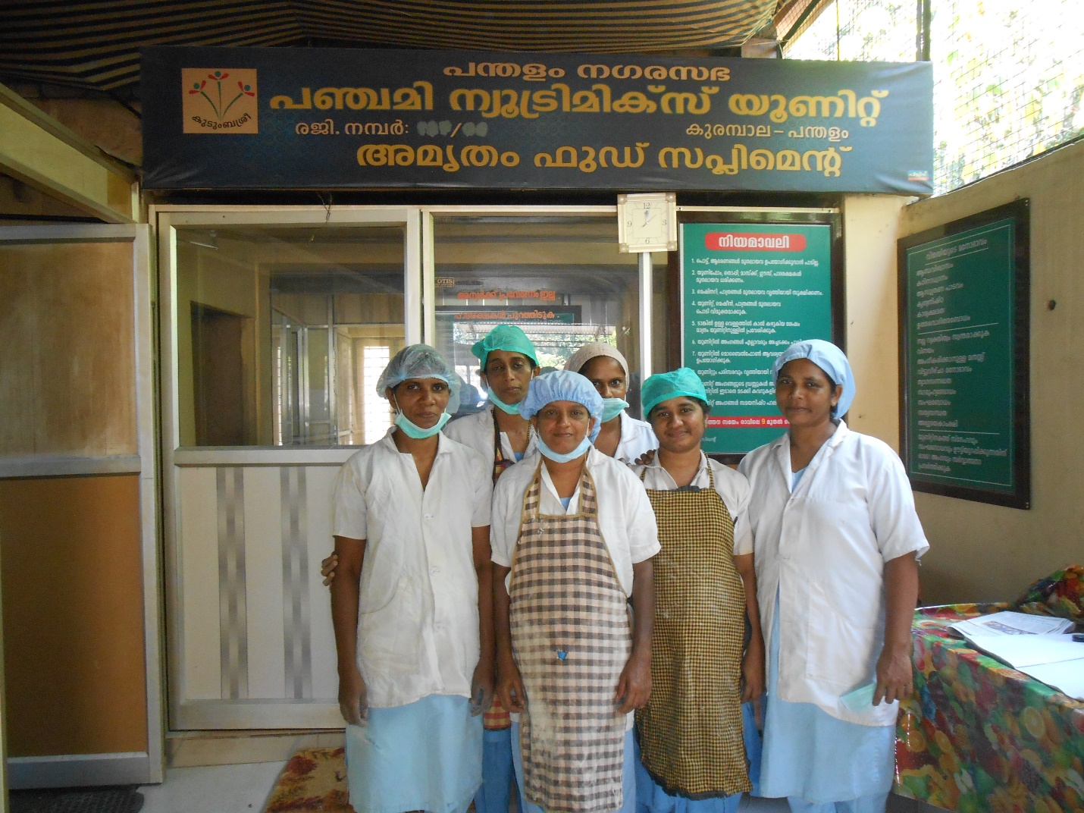

The unit has roaster, pulveriser, blender, sifter, mixing, packing and weighing machines for the production. The challenges they face are mostly related to the availability of funds as well as the rising prices of raw materials. The rising price of raw materials is probably the biggest challenge.